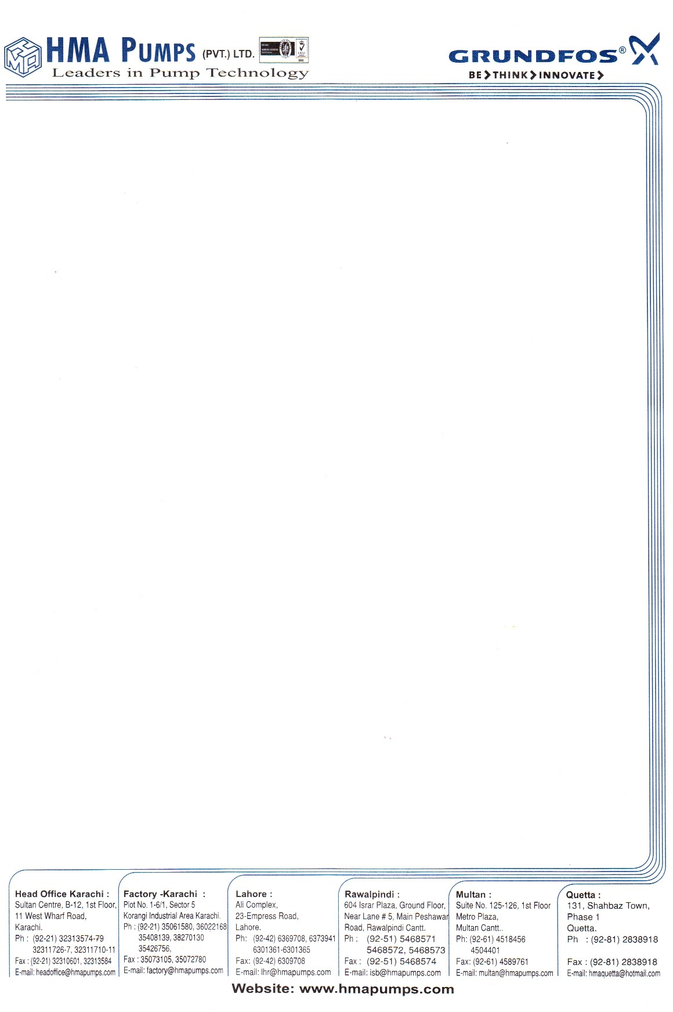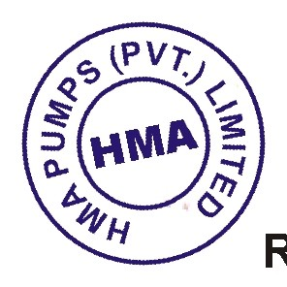

SERVICE CERTIFICATE

Certified that Mr. <Name> S/O Mr. <fname> worked with us as a <Designation> at HMA Pumps (Pvt.) Limited from <From> to <To>.

During his services period we found him hardworking intelligent and having vast experience in this field.

He left the services on his own accord.

We wish him every success in his future career.

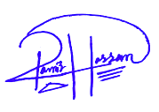

**RAZA HUSSAIN BAJWA**

**ADMIN & HR MANAGER**